Die homologe Reihe der Alkane
(allgemeine Summenformel: C _{n} H _{2n+2} )

Namen | Summenformeln | Strukturformeln
Methan | CH₄ | 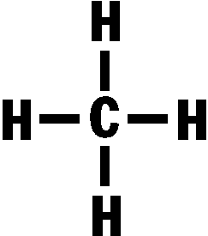
Ethan | C₂H₆ | 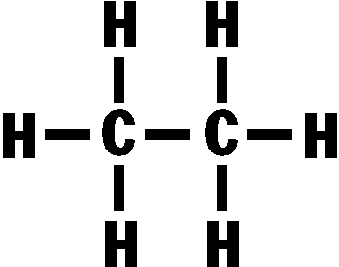
Propan | C₃H₈ | 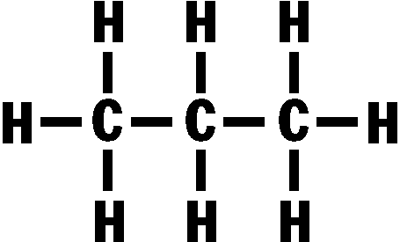
Butan | C₄H₁₀ | 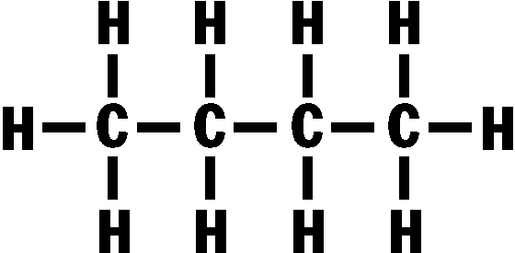
Pentan | C₅H₁₂ | 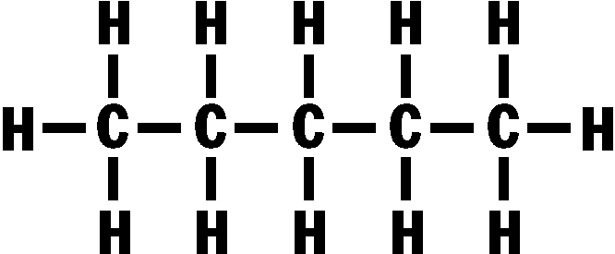
Hexan | C₆H₁₄ | 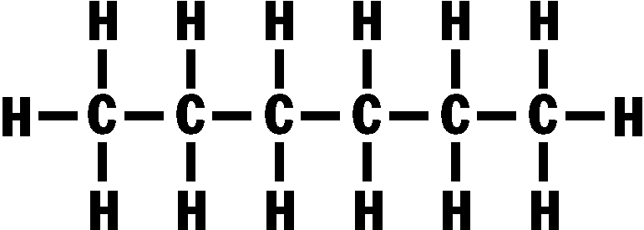
Heptan | C₇H₁₆ | 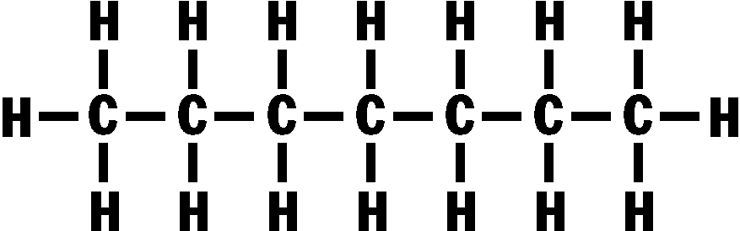
Octan | C₈H₁₈ | 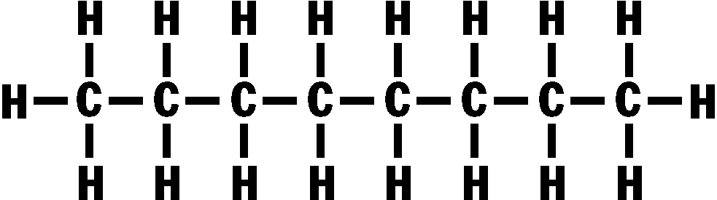
Nonan | C₉H₂₀ | 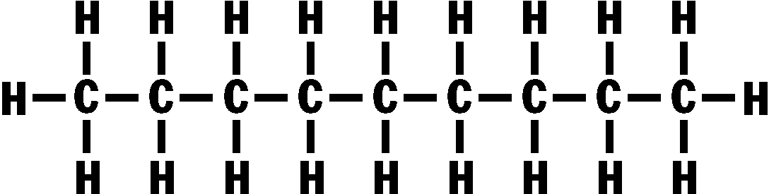
Decan | C₁₀H₂₂ | 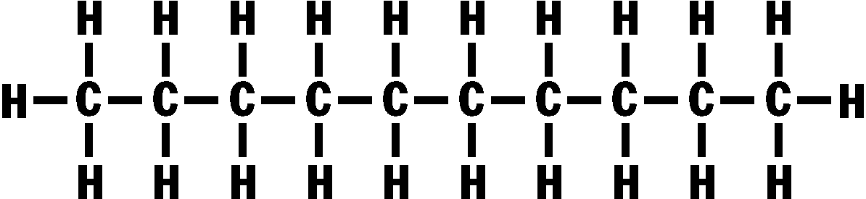
Undecan | C₁₁H₂₄ | usw.
Dodecan | C₁₂H₂₆
Tridecan | C₁₃H₂₈
Tetradecan | C₁₄H₃₀
Pentadecan | C₁₅H₃₂
Hexadecan | C₁₆H₃₄
Heptadecan | C₁₇H₃₆
Octadecan | C₁₈H₃₈
Nonadecan | C₁₉H₄₀
Eikosan | C₂₀H₄₂
Heneikosan | C₂₁H₄₄
Dokosan | C₂₂H₄₆
Trikosan | C₂₃H₄₈
Tetrakosan | C₂₄H₅₀
Pentakosan | C₂₅H₅₂

